# **PROJECT REPORT TEMPLATE**

INTRODUCTION

1. Overview

The project aims to provide actionable insights into the world’s first ten YouTube channel’s performance t from a subscriber’s perspective. The data visualizations generated will help the stakeholders gain insights into the growth trends, content preferences and audience engagement.

1. PURPOSE

* Mapping subscribers' locations can show where a channel has the most significant international reach.
* Visualizations can enable easy comparison between different channels, allowing viewers to see how subscriber counts vary across channels and regions.
* Visualizing demographic data of subscribers can offer insights into the age, gender, and location of a channel's audience.

PROBLEM DEFINITION & DESIGN THINKING

1. EMPATHY MAP

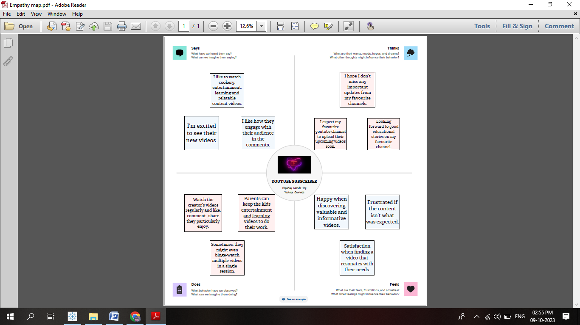

1. IDEATION & BRAINSTOMING MAP

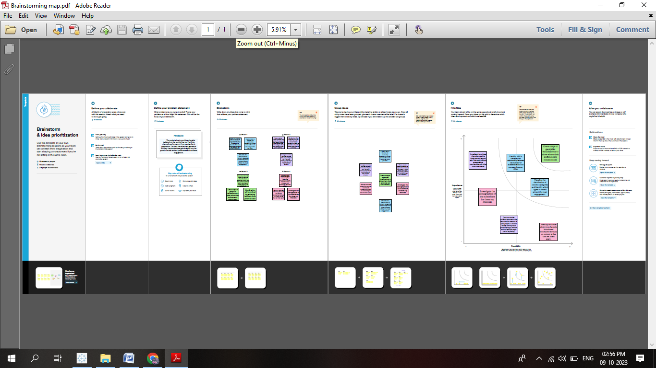

RESULT

DASH BOARD

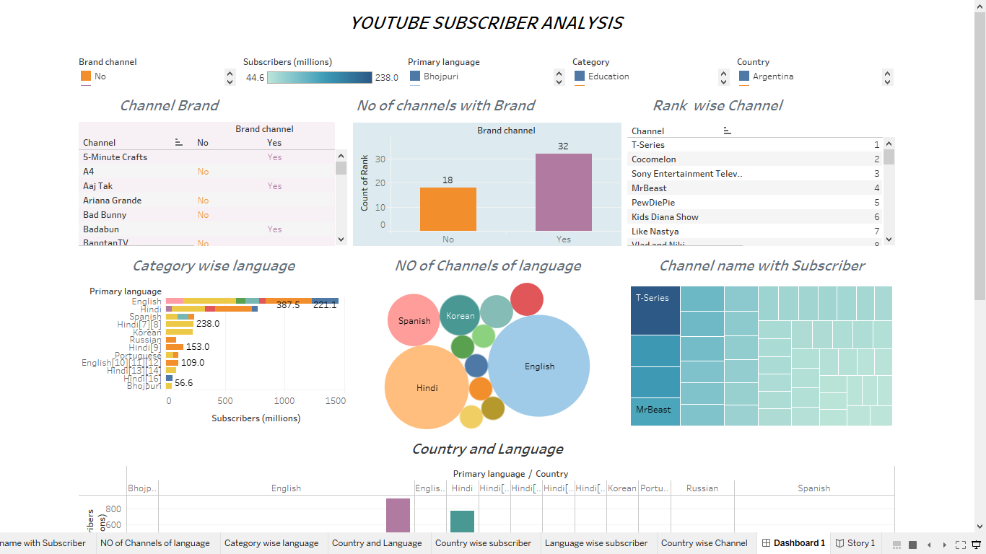

STORY

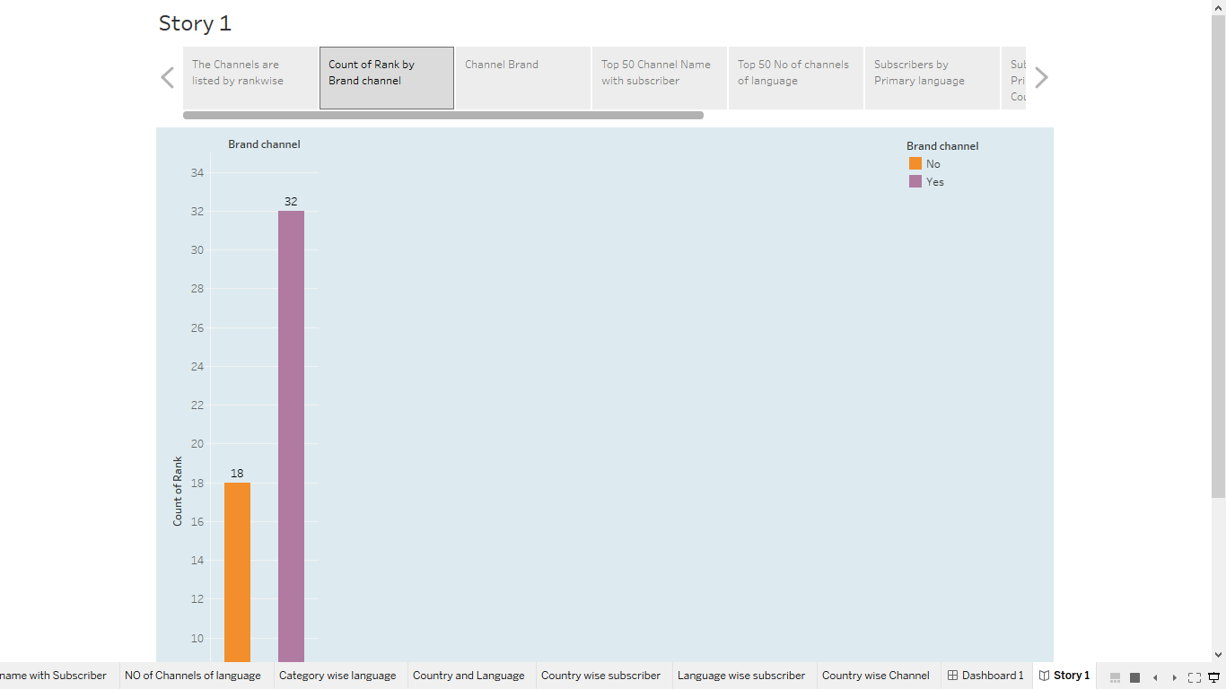

ADVANTAGES & DISADVANTAGES

ADVANTAGES

* Top channels often receive collaboration offers, free products, and invitations to events, providing various opportunities beyond YouTube.
* Creators can express themselves and pursue their passions while sharing content with a global audience.
* Brands are more likely to collaborate with channels that have a large and engaged subscriber base, offering lucrative sponsorship deals.
* With a substantial subscriber base, you can qualify for YouTube's monetization program, earning revenue through ads, Super Chats, and channel memberships.
* High subscriber counts can enhance your credibility and attract new viewers who trust popular channels.

DISADVANTAGES

* Maintaining a large subscriber base comes with the expectation of consistent, high-quality content, which can be stressful for creators.
* As your channel grows, your audience may diversify, making it challenging to cater to everyone's interests.
* YouTube's algorithm updates can affect channel visibility and revenue, making it challenging to adapt to shifting trends
* Maintaining a top YouTube channel can be incredibly demanding, leading to burnout, stress, and mental health challenges.
* Visualizations can enable easy comparison between different channels, allowing viewers to see how subscriber counts vary across channels and regions.

APPLICATIONS

* Create line charts to visualize the growth in subscribers for the top YouTube channels over time. This can help identify trends and patterns in their audience engagement.
* Line charts can be used to show the growth rate of subscribers for each channel, allowing you to identify periods of rapid growth or stagnation.
* Use bar graphs or radar charts to compare key metrics such as subscribers, views, likes, and comments among different channels. This can help identify leaders in various categories.
* Use retention curves to visualize how well channels are retaining their subscribers over time, indicating viewer loyalty.
* Utilize predictive visualizations like trendlines to forecast future subscriber counts or other metrics for these channels.

CONCULSION

* Identification of the most popular content categories among the top channels, such as gaming, entertainment, education, or lifestyle.
* Mapping the geographic distribution of these top channels and identifying regions with a strong YouTube presence.
* Examination of video formats, length, and frequency that are common among successful channels.
* The project could have highlighted how YouTube and its top channels have evolved over time, including changes in subscriber counts and content strategies.
* Insights into how these channels monetize their content, including advertising revenue, merchandise, and sponsorships.

FUTURE SCOPE

* Visualizations can be used to create compelling data stories that communicate channel performance and growth strategies to stakeholders and sponsors.
* Visualizing trends in content topics, video length, and upload frequency can help creators stay ahead of changing viewer preferences
* Data visualization can help creators and marketers understand their subscribers better by visualizing demographics, geographic location, and viewing habits. This information can be used to tailor content to specific audiences.
* For You Tubers seeking to monetize their channels, data visualization can provide insights into revenue sources, ad performance, and the impact of monetization strategies on overall channel growth.
* Predictive models using historical data can provide forecasts for subscriber growth, video performance, and revenue potential. Visualizations can make these predictions more accessible and actionable.